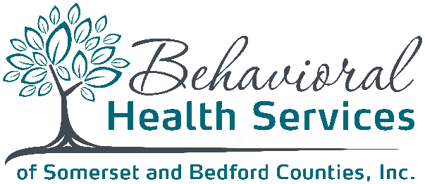
Board of Directors Meeting
February 22, 2023 - 12:00 pm
Microsoft Teams Meeting Click here to join the meeting
Or call in (audio only) +1 872-242-8079 ID: 396 032 024#

AGENDA

- Welcome/Roll Call (Sandra Benko)

- Review of Minutes from November 2022 Meeting (attached) (Sandra Benko)

- Welcome Melissa Baker – New CFO Role (Sandra Benko)

- HealthChoices Financial Review (Melissa Baker)
  - CY 2023 Budget Review and Approval

- HealthChoices Program Update (Cathy Krinjeck)
  - BHSSBC’s HC 2023 Contract
  - CCBH 2023 Contract
  - BHSSBC Board Report (attached)
  - BHSSBC Strategic Plan 2022 (attached)
  - BHSSBC Strategic Plan 2023 (attached)
  - Community Care Performance Incentives 2022 (attached)
  - Community Care Performance Incentives 2023 (attached)
  - HealthChoices Reinvestment Plans
  - Annual Policy Updates (May Meeting)
  - 2023 Quality Management Work Plan (draft)

- Other/ New Business
  - Review of Revisions to By-Laws (Sandra Benko)
  - Updated Organizational Chart for BHSSBC (Sandra Benko)
  - HRSA Grant Involvement (Cathy Krinjeck)
  - Training Calendar 2023 (attached) (Cathy Krinjeck)

- Next Meeting: May 24, 2023; 12:00 pm (location to be announced)

- Adjourn Meeting (Sandra Benko)

Thank you for attending!

